Chapter 10, Solution 5.

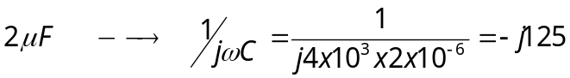

Consider the circuit as shown below.

I_{o} 2000 V_{o} -j125
+
_

25∠0º V j1000
+ 10I_{o}
–

At node V_{o},

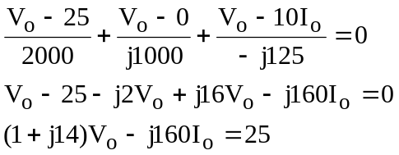

But I_{o} = (25–V_{o})/2000

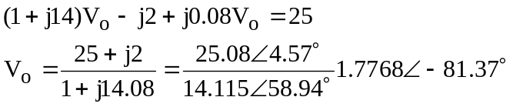

Now to solve for i_{o},

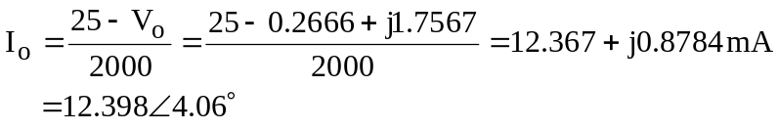

i_{o} = 12.398cos(4x10³t + 4.06˚) mA.

